Bài 2

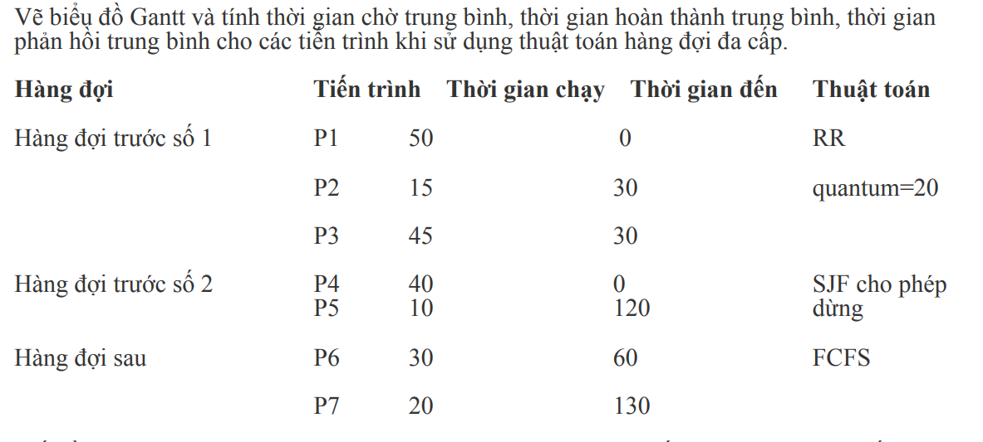

|  |  |  |  |  |  |  |
| --- | --- | --- | --- | --- | --- | --- |
| P1 | P1 | P2 | P3 | P1 | P3 | P3 |

0 20 40 55 75 85 105 110

|  |  |  |  |  |
| --- | --- | --- | --- | --- |
| P4 | P5 | P4 | P6 | P7 |

110 120 130 160 190 210

|  |  |  |  |
| --- | --- | --- | --- |
|  | Thời gian chờ | Thời gian hoàn thành | Thời gian phản hồi |
| P1 | 0 – 0 + 75 – 40 = 35 | 40 – 0 + 85 – 40 = 85 | 0 – 0 = 0 |
| P2 | 40 – 30 = 10 | 55 – 30 = 25 | 40 – 30 = 10 |
| P3 | 55 – 30 + 85 – 75 = 35 | 75 – 30 + 110 – 75 = 80 | 55 – 30 = 25 |
| P4 | 110 – 0 + 130 – 120 = 120 | 120 – 0 + 160 – 120 = 160 | 110 – 0 = 110 |
| P5 | 120 – 120 = 0 | 130 – 120 = 10 | 120 – 120 = 0 |
| P6 | 160 – 60 = 100 | 190 – 60 = 130 | 160 – 60 = 100 |
| P7 | 190 – 130 = 60 | 210 – 130 = 80 | 190 – 130 = 60 |
| Trung bình | 360 / 7 | 570 / 7 | 305 / 7 |